# Assessment of the global and regional geographical, technical and economic potential of onshore wind energy

Monique Hoogwijka , Bert de Vriesb , Wim TurkenburgPaul Denholm, Maureen Hand, Maddalena Jackson, and Sean Ong

**Abstract**

The regional and global geographical, technical and economic potential of onshore wind energy is assessed using a grid cell approach. For the economic potential, the regional cost – supply curves of wind electricity are presented. The global technical potential of wind electricity is estimated to be 96 PWh year 1 : about 6 – 7 times the present (2001) world electricity consumption at cut-off costs of about 1 US$ kWh 1 . To realise this potential, an area of 1.1 Gha is required when the wind turbines are installed at an average power density of 4 MW km 2 .

## Main points:

Future works??

* The studies (except Fellows, 2000) have resulted in aggregate estimations of the theoretical and technical potential and have dealt in only a limited way with the spatial distribution of wind turbine applications. The assessment can be improved by systematically using spatial data on average wind speed, land-use and land-cover data.
* Only two studies (World Energy Council, 1994; Fellows, 2000) have included economic factors in the assessment. However, the cost data of the World Energy Council (WEC) are now out of date and the Fellows (2000) only focuses in detail on four regions. The assessment can be improved using recent knowledge on wind electricity production costs around the world.
* The methodological approach in previous studies has been applied on wind energy only. We have also applied the approach to assess the potential of biomass energy and photovoltaic electricity using the same background data for the spatial distribution of land-use and population as in Hoogwijk et al. (submitted for publication). This enables to compare the potentials and simulate the future role of different renewable energy sources in the electricity market using an energy model such as TIMER 1.0 (de Vries et al., 2002).

Therefore, this study analyses the potential of onshore wind electricity. First, we assess the worldwide theoretical, geographical and technical potential of onshore wind energy for electricity generation based on present day technology. Second, we estimate the production cost of wind electricity and construct wind energy cost curves as a function of the technical potential. The study is conducted at a global level using a 0.5j 0.5j (longitude, latitude)2 land-use grid and a division of the world into 17 regions. We evaluate the major uncertainties and assess the sensitivity for key assumptions.

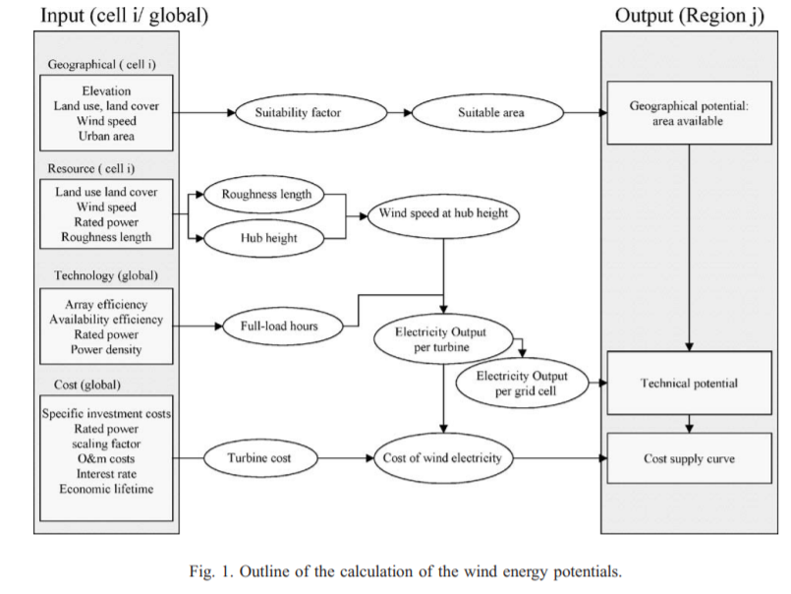

Definitions used in this study:

1. ***Theoretical potential*:** The total global energy content of the wind (kWh year 1 );

At grid cell level, it is conceptually difficult to calculate the power in the wind. The theoretical potential is rather derived from the theoretical solar energy reaching the atmosphere. King Hubbert (1971) estimated that the total wind power on earth is roughly equivalent to 2% of the solar energy reaching the atmosphere, which is about 3.5 1015 W

1. **Geographical potential:** The total global amount of land area available for wind turbine installation taking geographical constraints into account (km2 );

The first reduction in the theoretical potential in this study is the restriction to onshore areas only. However, offshore wind energy is excluded in this study because insufficient wind speed data are available to justify a proper analysis of the global offshore wind energy potential.

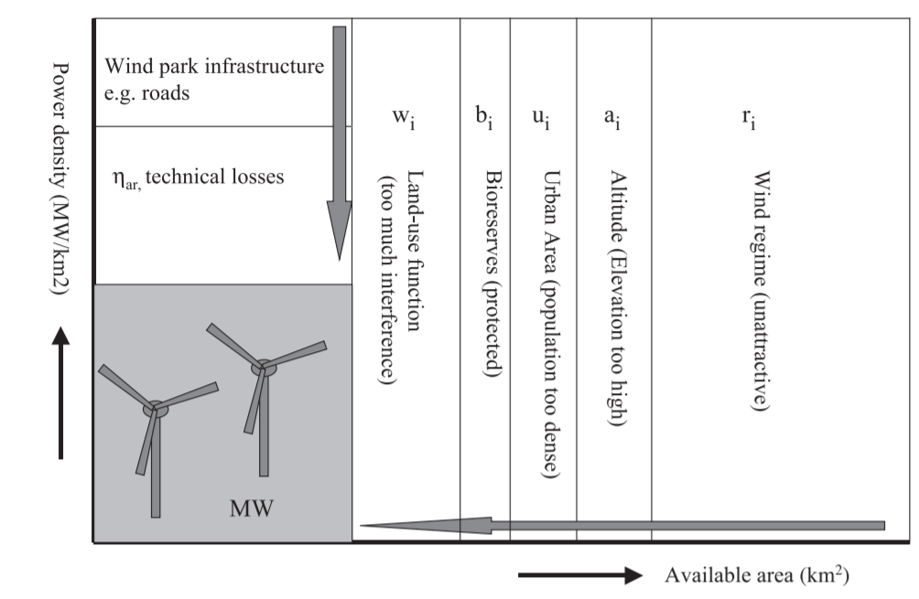

Geography potential:



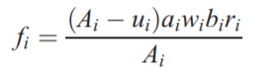

where **ui** is the urban area in cell i, **ai** is the binary weighting factor for altitude, **bi** is the suitability factor for bioreserves (0 if there are protected areas or areas with high natural values and 1 for all other areas), **wi** is the suitability factor for land-use and land-cover function of cell i, and **ri** is the suitability factor for wind regime restrictions.

1. **Technical potential***:* The wind power generated at the geographical potential including energy losses due to the power density of the wind turbines and the process of generating electricity using wind turbines (kWh year 1 );



where Ei is the wind energy output in grid cell i (kWh year 1 ), ga is the average availability of the wind turbine ( – ), gar is the wind farm array efficiency (– ), D is the power density (MW km 2 ), and hf,i is the full-load hours in grid cell i (h). Only the suitability factor fi (described above) and the full-load hours hf,i differ at grid cell level. The global technical potential Ei (kWh year 1 ) is expressed as the sum over all grid cells.

Wind speed= The data at grid cell level are constructed by interpolation of the measured data;

1. **Economic potential***:* The technical potential that can be realised economically given the cost of alternative energy sources (kWh year 1 ).

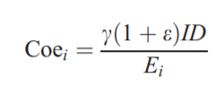

where Coei is the production cost of electricity in grid cell i (US$ kWh 1 ), c is the annuity factor (– ), and e is the cost of operation and maintenance, defined as fraction of investment cost, but included in annuity. The annual O&M costs are taken to be constant and scale-independent at a fixed fraction of the capital costs (e = 0.03). The investment cost I is determined by the specific turbine investment costs (It) and other costs such as foundation and grid connection costs

1. **Implementation potential***:* The amount of economic potential that can be implemented within a certain timeframe, taking (institutional) constraints and incentives into account (kWh year 1 ).

**Discussion of the results**

1. **Sensitivity analysis**

‘Strong’ knowledge (and so ‘strong’ parameters) is knowledge that is empirically measurable and controllable; we consider a parameter fair if it is estimated or calculated from measurable values. In this study, we consider the power density and the land-use suitability factor as ‘weak’ parameters. If wind turbines are installed, the power density can be measured. However, the maximum power density that is required for the technical potential is not measurable since it is a function of various social factors. Similar arguments apply for the suitability factors. The share of the agricultural land that can be used for wind turbine installation is among others a function of the value given to wind energy; that is, it has a high priority with respect to other land-use options. It is hard to define absolute ranges for these ‘weak’ parameters. Therefore, we first perform the sensitivity analysis of the ‘strong’ parameters before studying the sensitivity of the power density and the suitability factor.

The parameters that are considered to be more weakly underpinned, namely, the power density and the land-use suitability factors, are studied separately. These parameters have a high impact on the results, as summarised in Fig. 12. It shows the four extreme cost – supply curves for extreme values of land-use suitability factors (the values presented in Table 1 are default, low is 25% lower and high is 25% higher). The power density ranges from 0.1 MW km 2 in suitable area such as those found currently in the Netherlands and Germany (see Table 2) to 8 MW km 2 in suitable areas, equal to wind farm values.

1. **Comparison with previous studies**

We have compared the results of the onshore technical potential in detail with three previous studies:

1. the study by Grubb and Meyer (1993);

2. the WEC study conducted by Utrecht University (World Energy Council, 1994);

3. the IEA/OECD (2000) study conducted by Garrad and Hassan (Fellows, 2000).

The differences are caused by differences in the input parameters (e.g., wind speed, power density) and main assumptions (cut-off wind speed, land-use constraints). Some of the input parameters are difficult to compare, e.g., wind resource. However, to make a better comparison, we adjusted some input parameters and main assumptions. We assessed the technical potential using assumptions similar to those used in the other studies

**First**, all studies included only sites where ‘wind resources can be exploited’. Grubb and Meyer define these sites as having wind speeds above 6.0 m s 1 , the WEC defined the sites as having wind speeds above 5.1 m s 1 at 10 m. We used an exclusion wind speed of 4.0 m s 1 at 10 m. When the restriction of 5.1 instead of 4.0 m s 1 at 10 m is used, our estimate of the global potential falls by 60%, with large decreases (to even nil) in South Asia (see Fig. 13). The reason given for excluding these sites was the decision to include ‘exploitable’ sites only. We have included all sites where technically speaking large-scale wind turbines could be installed.

**Second**, the WEC excluded areas at a distance of more than 50 km from the existing grid. Due to lack of data on the electricity grid used in the WEC study, the effect of this assumption could not be studied quantitatively. Including this constraint may reduce our results.

**Third**, the overall power density is an important factor. The WEC study assumed a global average power density of 0.33 MW km 2 . This number is based on empirical studies concerning the optimal power density at national level and includes site constraints.

**Fourth**, in this study, the electricity output is calculated in a similar way as the WEC study and the study by Grubb and Meyer did, i.e., on the basis of the full-load hours. However, in the two previous studies, the amount of full-load hours per turbine was fixed in at 2000 and 2277 h, respectively. If a fixed amount of full-load hours at 2000 h is assumed, our results decrease 14% to a global technical potential of 83 PWh year 1 .

**Finally**, differences are caused by differences in the input parameter V10. We could not reassess our calculations with the wind speed data of the previous studies. Hence, we were unable to compare the influence of the input parameter V10 on the results. Fellows (2000) have been able to compare his data with other digital data for the USA. It was concluded that their database underestimated the wind speed and corrections were made for the overall results. This could not be done in this study.

## Possible solutions (work that WE can do)

1. I understood that the **weakest factor** in this study was the assessment of wind speed and power density. Thus, we should focus on evaluate how to evaluate this input with another articles, or do by ourselves the analysis.
2. Chose a region, like: Netherlands only, and do the same analysis again with actual data (HARD CHOICE!)
3. Do sensitivity analysis of the study with new parameters, like: sustainable aspects, durability of the system (how many years), new ways to build wind turbines and agricultural farms next to building area.
4. Challenge the main concept: Is better to build LARGE wind turbines or small scale, like to sustain only microregional uses: houses, farms, small scale industry, … With this more granular way of wind, maybe we can improve the total system power (hypothesis)

## How this work can be done